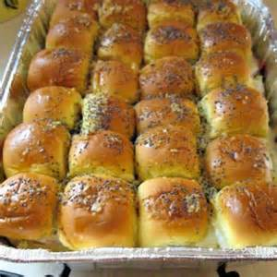
Sticky Ham and Cheese Buns

(Served at August 16 meeting)

There are many versions of this recipe on Pinterest. Here is the way Eileen Frankil made it.*

Three dozen small Kings Hawaiian buns
36 thin slices of ham- about ¾ pound
36 thin slices of swiss cheese – about ¾ pound
½ cup Mayonnaise

Sauce:
½ cup (1 stick) butter
1 Tablespoon mustard
1 Tablespoon Worcestershire sauce
2 Tablespoons Brown Sugar
1 Tablespoon poppy seeds

In small saucepan, bring all sauce ingredients to a boil. Lower the heat and let simmer for a few minutes. Set aside.

Slice buns in half. Put a bit of mayonnaise on top and bottom of each bun. Add a slice of ham and a slice of cheese to each and assemble sandwiches. Place tightly packed into a couple of baking dishes. Pour sauce all over, using a spatula to make sure they are all coated. Cover with foil and let marinate in fridge for at least one hour, or overnight.

Bake in preheated 350 degree oven for 10 minutes covered, and an additional 10 minutes uncovered.

NOTE: Other recipe versions use 12 or 24 buns with same amount of sauce. Eileen used 36 buns. Using fewer buns would be much stickier and sweeter.

